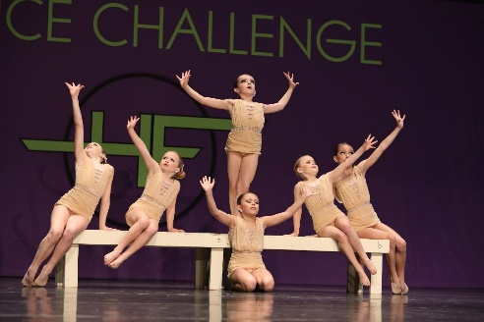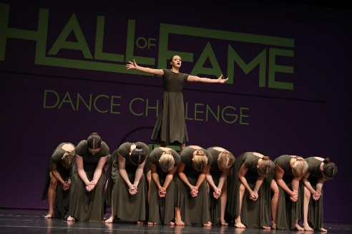
2021-2022 NLDC Competition Team Tryouts

We are so proud of our incredible team! This season we will be celebrating our 13th season of dance excellence!!

Here is some information you will need if your dancer is attending one of our auditions:
Audition Fee: $10.00 may bring cash/check or Venmo @NLDC-NLDCTampa
Please fill out the audition form
Dancers may review and learn a combination off the newleveldance.com website prior to their audition date for their level. Our beginner dancer and minis will be taught a routine at the actual audition.

Dress Attire For Auditions:
Any dance attire! (Hair pulled back out of face) Twylas or barefoot for the contemporary routine.

What is the Cost for the NLDC Competition Team?
*Mini Team fee is $200.00 for the season
*There will be a team fee of $350.00 for the season for all other team members
*All team members are highly encouraged to attend “Summer Insanity” intensive July 26th- 29th. If that date does not work for some reason, the dancer must be enrolled in another intensive at New Level.
*We also have a mandatory August Choreography Camp to begin learning routines. That intensive is $250.00 and will cover up to 4 group routines learned. Please block off the dates August 4th-6th as well as August 9th-13th for choreography.
*If you allow your dancer to be in more than 4 group routines, there will be a charge of $50.00 per additional dance to cover the cost of choreography.
*There is a $175.00 prop fee for the year unless you sign up to help with props (a minimum of two competitions) or help with rhinestoning/sewing costumes.
*Competitions charge about $55.00-$65.00 per group dance each time it competes, solos and duets are more but optional.
*Registration fee per competition/convention is $10 per dancer (this is to cover all of the time it takes to register every individual/each of their dances/upload all music/etc...
*Costume fees per dance range from $75.00-$115.00

Optional Fees:
We will post a solo chart with the dancer’s selected style & choreographer after the last audition, you will have the opportunity to let us know how many solos and duet/trios you would like and the preferred dance style! After receiving the chart, you may contact the choreographer/choreographers to set up rehearsal times.
*Solos cost $350.00 Choreography Fee. This includes one hour of rehearsal. The routine will be finished in private lessons at the private lesson rate.
*Duets cost $175.00 per dancer Choreography Fee and for Trios $117 per dancer for a trio. To be finished in private lessons.
*Private lesson fees $70.00 per hour or $35.00 for 1/2 hour

Time Commitment:
All team members must attend their scheduled weekly practice along with the scheduled Saturday practices. If you are in high school and belong to a dance/cheer team we will work with you on the number of missed absences. We feel it’s important to enjoy your high school experience and also keep up with your
competitive dance training.

Team Commitment:
New Level team members are EXCLUSIVE to NLDC. We strive for a cohesive team that trains together in order to achieve the highest results. We try our best to provide top notch training which is well received and respected at competitions. Aside from our classes, there will be plenty of opportunities to continue your dance growth through conventions, our summer program/intensives/classes, etc...

Summer Requirements:
All team members are REQUIRED to attend one intensive (Summer Insanity preferred) in addition to the choreography week.

Weekly Class Requirements:
Elite Teams - rehearsal class, 2-3 ballet/pointe, jazz/contemporary, turns & leaps, stretch/condition or acro (tap/hip hop/aerial arts are optional but highly encouraged)
Cutting Edge Petite - rehearsal class, 1 ballet, jazz/contemporary, turns & leaps (acro/tap/hip hop/aerial arts are optional but highly encouraged)
Minis - 2 or more hours per week (includes a rehearsal class and a dance class)

Competition Locations:
All Teams compete in Tampa, Lakeland & Orlando (Elite Teams may travel a little further)

Good luck at the audition dancers!

